- Write a program to replace a substring inside a string with other string ?
public class Ques1 {
public static void main(String[] args) {
String ReplaceString="hi my name is shubham verma";
System.out.println(ReplaceString.replaceAll("a", "aasdasda"));
}
}
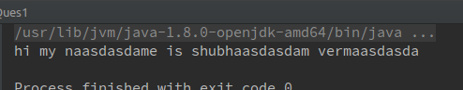
- Write a program to find the number of occurrences of the duplicate words in a string and print them ?

import java.util.HashMap;
import java.util.Map;
import java.util.Scanner;
/**
* Created by hackerfreak on 19/6/17.
*/
public class Ques2 {
public static void main(String[] args) {
System.out.println("enter the string");
Scanner scan = new Scanner(System.in);
String input = scan.nextLine();
String[] words = input.split(" ");
Map<String, String> wordMap = new HashMap<String, String>();
Map<String, String> printedMap = new HashMap<String, String>();
for (int i = 0; i < words.length; i++) {
String word = words[i].toUpperCase();
if (wordMap.get(word) != null) {
if (printedMap.get(word) == null) {
System.out.println("Duplicated/Repeated word:" + word);
printedMap.put(word, word);
}
} else {
wordMap.put(word, word);
}
}
}
}

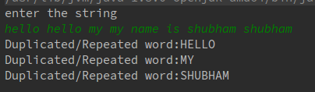

- Write a program to find the number of occurrences of a character in a string without using loop?
import java.util.Scanner;
/**
* Created by hackerfreak on 19/6/17.
*/
public class Ques3 {
public static void main(String[] args) {
char c;
Scanner scanStr=new Scanner(System.in);
String countOccurance=scanStr.nextLine();
countOccurance.toLowerCase();
System.out.println("enter the char");
c=scanStr.nextLine().charAt(0);
System.out.println(
countOccurance.length()-countOccurance.replaceAll(String.valueOf(c),"").length());;
}
}
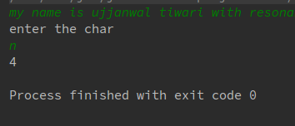

- Calculate the number & Percentage Of Lowercase Letters,Uppercase Letters, Digits And Other Special Characters In A String
import java.util.Scanner;
/**
* Created by hackerfreak on 19/6/17.
*/
public class Ques4 {
public static void main(String[] args) {
System.out.println("enter the string");
Scanner scan = new Scanner(System.in);
String input = scan.nextLine();
int lowerCaseCount=0;
int upperCaseCount=0;
int digit=0;
int special=0;
double lowerCasePercent,upperCasePercent,digitPercent,specialCharPercent;
char Char;
for(int i=0;i<input.length();i++)
{
Char=input.charAt(i);
if (Character.isUpperCase(Char)){
upperCaseCount++;
} else if (Character.isLowerCase(Char)){
lowerCaseCount++;
} else if (Character.isDigit(Char)){
digit++;
} else{
special++;
}
}
lowerCasePercent=(lowerCaseCount*100)/input.length();
upperCasePercent=(upperCaseCount*100)/input.length();
digitPercent=(digit*100)/input.length();
specialCharPercent=(special*100)/input.length();
System.out.println("upper case count is : "+upperCaseCount+" and percentage is: "+ upperCasePercent);
System.out.println("lower case count is : "+lowerCaseCount+" and percentage is: "+ lowerCasePercent);
System.out.println("digit count is : "+digit+" and percentage is: "+ digitPercent);
System.out.println("special char count is : "+special+" and percentage is: "+ specialCharPercent);
}
}
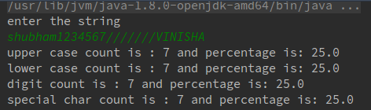

- Find common elements between two arrays.
public class Ques5 {
public static void main(String[] args) {
int []array= {12,13,26,24,58,96,45};
int []array1= {96,20,24,30,40,13,50};
for (int i=0;i<array.length;i++)
{
for (int j=0;j<array1.length;j++)
{
if(array[i]==array1[j])
System.out.println("duplicate element found "+array[i]);
}
}
}
}
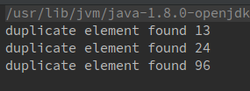

- There is an array with every element repeated twice except one. Find that element?
/**
* Created by hackerfreak on 19/6/17.
*/
public class Ques6 {
public static void main(String[] args) {
int []array={1,1,2,2,3,3,4,5,5};
int Unique=array[0];
for(int i=1;i<array.length;i++) {
Unique = Unique ^ array[i];
}
System.out.println(Unique);
}
}
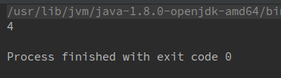

- Write a program to print your Firstname,LastName & age using static block,static method & static variable respectively
/**
* Created by hackerfreak on 19/6/17.
*/
public class Ques7 {
static {
System.out.println("shubham");
}
public static void main(String[] args) {
StaticDemo.DisplayLastName();
System.out.println(StaticDemo.age);
}
static class StaticDemo{
static int age=23;
static String last_name="verma";
public static void DisplayLastName(){
System.out.println(last_name);
}
}
}

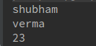

- Write a program to reverse a string and remove character from index 4 to index 9 from the reversed string using String Buffer.
import java.util.Scanner;
/**
* Created by hackerfreak on 20/6/17.
*/
public class Ques8 {
public static void main(String[] args) {
System.out.println("enter a string");
Scanner scanner=new Scanner(System.in);
String StringToReverse=scanner.nextLine();
System.out.println(StringToReverse);
String reversed=new StringBuffer(StringToReverse).reverse().toString();
System.out.println(reversed);
String removedChar=new StringBuffer(new StringBuffer(reversed).deleteCharAt(4).toString())
.deleteCharAt(9).toString();
System.out.println(removedChar);
}
}

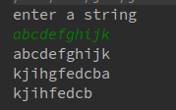

- Write a program to read text file & print the content of file using String Builder.
import java.io.BufferedInputStream;
import java.io.FileInputStream;
import java.io.FileNotFoundException;
import java.io.IOException;
/**
* Created by hackerfreak on 20/6/17.
*/
public class Ques9 {
public static void main(String[] args) throws IOException {
FileInputStream fileInputStream= null;
try {
fileInputStream = new FileInputStream("/home/hackerfreak/Desktop/list.txt");
} catch (FileNotFoundException e) {
e.printStackTrace();
}
BufferedInputStream bufferedInputStream=new BufferedInputStream(fileInputStream);
StringBuilder s=new StringBuilder("");
int i;
while((i=bufferedInputStream.read())!=-1)
{
s.append((char)i);
}
bufferedInputStream.close();
fileInputStream.close();
System.out.println(s);
}
}
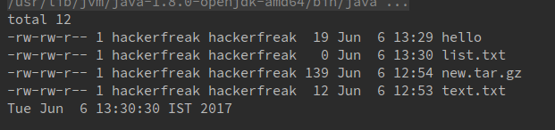
- Write a program to display values of enums using a constructor & getPrice() method(Example display house & thier prices ).
/**
* Created by hackerfreak on 20/6/17.
*/
public class Ques10 {
public static void main(String[] args) {
for (HousePrices x:HousePrices.values()) {
System.out.printf("price of "+x+" "+" "+x.getPrice()+"crore\n");
}
}
}
enum HousePrices{
VILLA(2), Bunglow(3), PENTHOUSE(7);
private int price;
HousePrices(int i) {
price=i;
}
int getPrice()
{
return price;
}
}
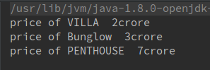

- Write a single program for following operation using overloading A) Adding 2 integer number B) Adding 2 double C) Multipling 2 float d) Multipling 2 int E) concate 2 string F) Concate 3 String
/**
* Created by hackerfreak on 20/6/17.
*/
public class ques11 {
public static void main(String[] args) {
Addition I=new Addition();
I.add(2,3);
I.add(2.5,3.5);
Multiplication multiplication=new Multiplication();
multiplication.mul(3,5);
multiplication.mul(3.5f,2.5f);
StringOperation SO=new StringOperation();
SO.concat("shubham","verma","TTN");
}
}
class Addition{
public void add(int x,int y)
{
System.out.println(x+y);
}
public void add(double x,double y)
{
System.out.println(x+y);
}
}
class Multiplication{
public void mul(int x,int y)
{
System.out.println(x*y);
}
public void mul(float x,float y)
{
System.out.println(x*y);
}
}
class StringOperation{
public void concat(String a,String b){
StringBuilder sb=new StringBuilder(a);
sb.append(b).toString();
System.out.println(sb);
}public void concat(String a,String b,String c){
StringBuilder sb=new StringBuilder(a);
sb.append(b).toString();
sb.append(c).toString();
System.out.println(sb);
}
}
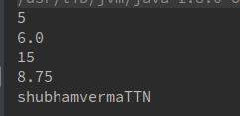

- Create 3 sub class of bank SBI,BOI,ICICI all 4 should have method called getDetails which provide there specific details like rateofinterest etc,print details of every banks

/**
* Created by hackerfreak on 20/6/17.
*/
public class Ques12 {
public static void main(String[] args) {
System.out.println(Bank.getDetails());
System.out.println(BOI.getDetails());
System.out.println(ICICI.getDetails());
System.out.println(SBI.getDetails());
}
}
class Bank{
static public int getDetails(){
return 0;
}
}
class SBI extends Bank{
static int roi=20;
static public int getDetails()
{
return roi;
}
}
class BOI extends Bank{
static int roi=15;
static public int getDetails()
{
return roi;
}
}
class ICICI extends Bank{
static int roi=25;
static public int getDetails()
{
return roi;
}
}

